ME 4053: Fall 2025

Homework #2

Beam deflection & Lift/Drag Calculations

M. Anderson & E. Severson

Mechanical Engineering Department

University of Minnesota

Due: October 25th, 2025

For this assignment you are to solve the following questions using various numerical methods in MATLAB. Leveraging built-in functions is acceptable, and encouraged. For the deliverables there are two separate gradescope submission links, one for a single .pdf that has the the final answers and plots for each question and a second for two (2) MATLAB scripts, one for each question. In order to earn full marks the script files are required to run on their own and be well formatted and commented.

Q1 - Cantilevered beam Analysis (5 points). Consider the cantilevered beam drawn below. It is subject to a uniform load over the first 6m, as indicated in the diagram.



* 1. Determine the effective point load (magnitude and x location) on the beam
  2. Determine the reaction force / moment
  3. Determine expressions for the internal shear V and bending moment Mb as a function of x
  4. Determine the angle and deflection of the beam as a function of x, given a constant flexural rigidity of EI = 250,000 Nm2.
  5. Use MATLAB to create a shear force bending moment diagram. Show this as a set of vertically aligned plots (hint: use the subplot command) depicting q, V, Mb , θ, and δ over the full length of the beam. Use the sign convention introduced in the lecture. Use appropriate axes labels and submit your MATLAB script that creates these plots.

Note: It is recommended that you write your code in such a manner that it could handle a changing cross section and non constant load as then the code will be more easily transferable to your project.

Q2 - Calculation of relative velocity (5 points)

Write a free-standing MATLAB function to perform the trigonometric calculations that are necessary to determine the angle of attack for a 3-bladed lift-based HAWT. The input arguments/output arguments for the function are shown in Figure 1.

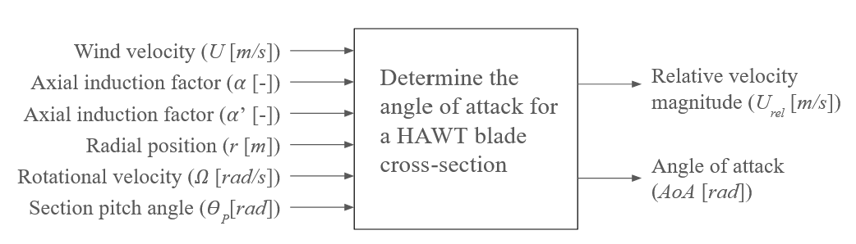

**Figure 1:** Function behavior

As discussed in lecture the schematic for a slice of a wind turbine blade in the $z-θ$ plane at a given radial position is shown in Figure 2 below.

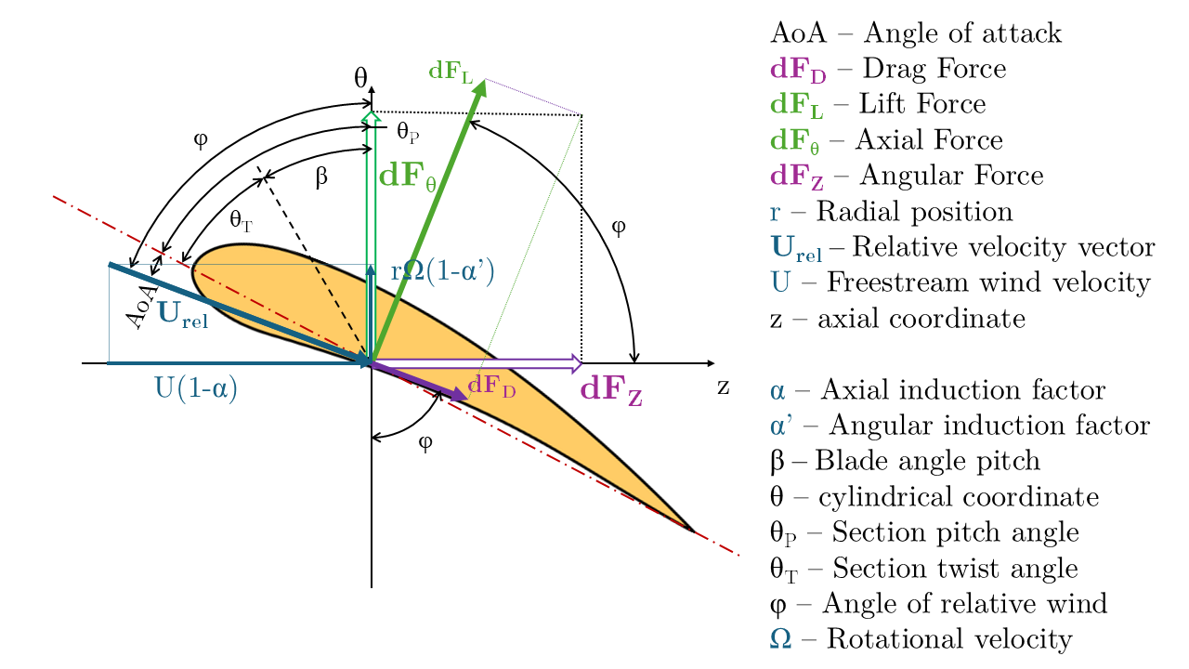

**Figure 2:** Blade profile schematic in the $z-θ$ plane

Note the following nomenclature:

* *AoA* – Angle of attack
* *dFD* – Drag Force
* *dFL* – Lift Force
* *dFθ* – Axial Force
* *dFZ* – Angular Force
* *r* – Radial position
* *Urel* – Relative velocity vector
* *U* – Freestream wind velocity
* *z* – axial coordinate
* α – Axial induction factor
* α’ – Angular induction factor
* β – Blade angle pitch
* θ – cylindrical coordinate
* θP – Section pitch angle
* θT – Section twist angle
* φ – Angle of relative wind
* Ω – Rotational velocity

There are no specific test cases for this assignment, it is up to you to confirm the accurate behavior of your code. The teaching team will evaluate the performance of this function upon submission. The code should be able to handle both scalar and array (vector) inputs.